Pervasive Computing and ADHOC sensors applied to MOTOHEALTH

Second Generation Sensors SOW
Fabio Grigorjev - MOTOHEALTH

Background

MOTOHEALTH supports up to five sensors in version R02.00.00. The independence achieved by using JSR-82 (Bluetooth API) in R01.02.00 was a good advantage since it allowed MOTOHEALTH interact with several sensors using Bluetooth in their physical layer.
The main drawback is that the sensor’s protocol (propietary) has to be hard-coded for each of the current sensors, this does not allw MOTOHEALTH to suport a wide variety of sensors and any change is costly and hard to implement.
This document proposes to adopt a new industry standard for MOTOHEALTH to support pervasive computing and ADHOC network features. This characteristic could be achieved by adding the new mobile sensor API (JSR256) and providing clear specifications and a reference implementation for sensor’s vendors that want to be in the MOTOHEALTH body area network.
The JSR 256 Mobile Sensor API that allows J2ME application developers to fetch data easily and in a uniform way from sensors. A sensor is any measurement data source. Sensors vary from physical sensors like magnetometers and accelerometers to virtual sensors, which combine and manipulate the data they have received. Examples of virtual sensors could be for example battery level sensor indicating the remaining charge in a battery, or a field intensity sensor that measures the reception level of the mobile network signal in a mobile phone. The sensor may be connected to the mobile device in different ways, represented by the connection type. Currently defined connection types are embedded, short range wireless, wired and remote.
The API also provides means to monitor retrieved data values. The application can register a listener and set limits and ranges for monitoring. If the measured value meets any of defined conditions the listener is notified.
The API does not provide any methods to control the sensor; it only provides methods for receiving the information from the sensor. Examples of possible control methods are starting, stopping, calibrating and setting the measurement range. These are left out for simplicity and the implementation should take care of this functionality automatically.
The Mobile Sensor API can be used with any profile running on top of either the Connected, Limited Device Configuration (CLDC) or the Connected Device Configuration (CDC).

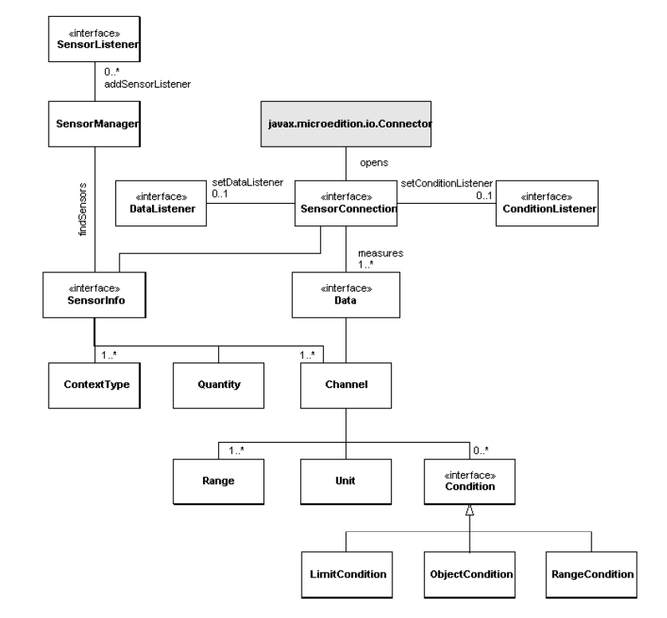
Figure 1
Class Hierarchy

As complementary background use case is presented.

Use Case: MOTOHEALTH Allergic patient need to know about air quality.

FG Ellectronics produces a little Air Quality sensor, this sensor is a simple microcontroller based sensor in air context that send via ZigBee, every hour, the following data:

- Overall Pollen
- Grass Pollen
- Weed Pollen
- Tree Pollen
- Air Quality

Pollen is measured using None, Low, Moderate, High, Very High.
Air Quality is quantified using Good, Moderate, Unhealthy, Very Unhealthy, Hazardous.

The little sensor is installed in all working areas, shoppings, cinemas and restaurants.

Case Description: When a MOTOHEALTH patient's phone (allergic profile) receives the broadcasting of the pollen sensor via ZigBee, no matter if the MOTOHEALTH application is running or not in that moment, the pushregistry wake-up the application and send the data to the MOTOHEALTH server. (Please notice that this JSR allows MOTOHEALTH application using PushRegistry mechanism in the future.)

Notice that this data collection is seamless and transparent to the user.
Two actions can be performed on that moment:

- An advice is shown to the patient, indicating that the Overall Pollen is Very High in that environment. (Close loop using RangeCondition API's utilities).
- The channels are sent to the server for further treatment.

The use case only illustrate (not limited to) the possible use of the implementation. Depending on the context and sensors the implemention will be ready (not limited to) to support a wide range of sensors, i.e:

Context Type | Additional Context Type | Quantity | Sensor
Air | Ambient | Temperature | Thermometer
Air | Ambient | Pressure | Barometer
Air | Ambient | Humidity | Humiditymeter
Alcohol | User, breath | Percentage | Alcometer
Barcode | Ambient | Pattern | Barcode reader
Blood | User | Pressure | Sensor Measuring Blood Pressure
Body | User | Temperature | Clinical Thermometer
Body | User | Mass | Weight Scale
Breath | User | Volume | Spirometer measuring volume of lungs
Data | Device | Amount | Sensor measuring data amounts
Fingertip | User | Pattern | Fingertip sensor
Glucose | Blood, user | Level | Glucometer
Health | User | Level | Fitness category sensor, which gives estimate of the user’s condition
Heart | User | Frequency | Sensor measuring heart rate
Image | Ambient | Pattern | Camera
Motion | User | Speed | Velocimeter
Motion | Ambient | Level | Motion detector
Oxygen | Blood, user | Level | Oxymeter
Particle | Ambient | Concentration | Sensor measuring dust in the air
Pollution | Air, Ambient | Level | Sensor measuring levels of various kind of pollutant
Radiation | Ambient | Absorbed dose | Radiation sensor
Skin | User | Temperature | Clinical Thermometer
Smoke | Ambient | Level | Smoke detector
Sound | Ambient | Intensity | Microphone
Step | User | Amount | Pedometer
Tilt | Ambient | Angle | Accelerometer
Water | Ambient | Temperature | Sensor measuring water temperature
Weather | Ambient | State | Weather Forecast sensor

Objective

In order to avoid the sensor dependecy, MOTOHEALTH wishes to have a normalized API and a Reference Implementation of a MOTOHEALTH generic sensor for providing to vendors adequate specifications according MOTOHEALTH needs.
The model porposed to be implemented is much more flexible than previous and includes dynamic sensor identification by creating a driver system support that allow the MOTOHEALTH MIDlet to use any kind of sensor, any kind of physical transmition only implementing the appropiated driver. The project shall deliver a working implementation of the driver that shows the interaction of a generic (and simple) sensor and a J2ME CDLC1.1 phone (i870, A1000).

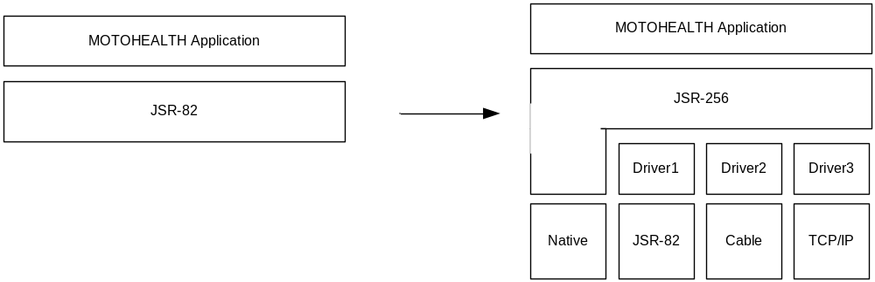

Description and Scope of Work

The contractor shall work in contact with Motorolans involved in Sun’s JSR-256 approval. Also the contractor will use the latest Sun’s site documentation regarding the mentioned Java Community Process.
The contractor will identify personnel with skills in Static Factory Design Pattern and Low level protocol design for this work.
The contractor shall provide all the deliverables and results of the investigation to MOTOHEALTH group as well as the specifications and analysis created.

Deliverables and Schedule

The contractor shall complete the following tasks, activities, deliverables and milestones:

4.1 Creating a MOTOHEALTH sensor driver specifications: The contractor shall create a clear and understable sensor driver specification that allow vendors to provide the sensor description according to MOTOHEALTH interface.
4.2 Creating Reference Implemention (RI): The contractor shall create a reference implementation that contains a PC-based emulated sensor, Bluetooth dongle, java-implemented mobile sensor API on i870 or A1000 and the driver that demonstrate the capabilities of generic sensors according to JSR256 specifications.
4.3 Creating a JSR256 API implementation: The contractor shall create a JSR256 implementation as it is today that shall run on i870 and A1000 phones.

Deliverable | Deadline/Schedule
MH sensor specifications
Reference Implementation (RI)
API implementation

Departmental Responsibilities and Support

No special responsibilities and support are needed other than the current MOTOHEALTH environment.

Location of Work and Travel

It is anticipated that the majority of the work will be carried out in the contractor site. There may be a requirement for travel to Plantation offices. Other trips made by MOTOHEALTH Project Leader might be used for synchronizing this work.

Security Requirements

No special requirements.

Duration/Period of Agreement

TBD

Language of Work

Written communication will be English.
The language of work with MOTOHEALTH personnel will be English.

Personnel Replacement and Substitutions

The contractor must provide the services of the personnel named in MOU, unless the contractor is unable to do so for reasons beyond his control.

Departmental Representative

The contractor shall report and provide deliverables to Tamara Simpkins Franklin, Director of New Business Development & Specialty Products, iDEN Networks & Devices.

In computing, a reference implementation (or, infrequently, sample implementation) is a software example of a standard for use in helping others implement their own versions of the standard. A standard is much easier to understand with a working example to hand.

